# Introduction

Most Assistive Switches are momentary switches – the output is activated when they are pressed and deactivated when they are released. For some applications, it is useful and desirable to be able to use a single movement to activate a device and have it remain on, then use another single movement to turn the device off some time later. For example, a user may want to turn on a fan or a light and have it remain on without having to continuously activate (e.g., hold down) their switch.

There are a couple of commercial options that provide a Switch Latch functionality, however these are very expensive. The objective of this project was to develop a low-cost, open-source device capable of toggling the output of a momentary assistive switch.

The intended users of the OpenAT Switch Latch are those who require a momentary switch to act as a toggle switch (aka latched switch), allowing the user to turn on for an extended time with a quick tap, and off again with another quick tap.

# Research

## Commercial Options

### AbleNet Dual Switch Latch & Timer

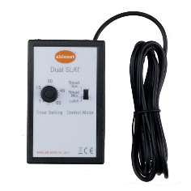The **Dual Switch Latch & Timer** by Adaptive Tech Solution **$305.22**

[Switch Latch & Timer (adaptivetechsolutions.com)](https://www.adaptivetechsolutions.com/dual-switch-latch-timer/)

The Dual Switch Latch and Timer gives switch users more control of their devices by adding time and latch modes of control. You can setup two switches into the Switch Latch and timer. The switches will operate their corresponding toy or appliance independently of each other in the same mode of control.

### Switch Capable Continuous Control Unit

can be used to operate most AC appliances from up to 20 feet away**.** List Price: **$315.40 Sale** Price: **$220.56** (Save 30%)

The Switch Capable Continuous Control Unit can be used to operate most AC appliances from up to 20 feet away. Activate the remote transmitter with a capability switch after plugging the appliance into the receiver. In latch mode, the appliance will run until the switch is pressed again; **in momentary mode, it will turn on when the switch is pressed and off as soon as the switch is released.**

### PowerLink 4

[**https://www.ablenetinc.com/powerlink-4-north-america/**](https://www.ablenetinc.com/powerlink-4-north-america/)

**Cost: $330 USD + Shipping**

Used to turn on appliances that are powered from a wall outlet.

### Latch Box

Link: <https://oneswitch.org.uk/art.php?id=276>

Cost: £40 (+ postage) (~$62 CAD + shipping)

Power: 3x AAA batteries OR USB (Micro-B)

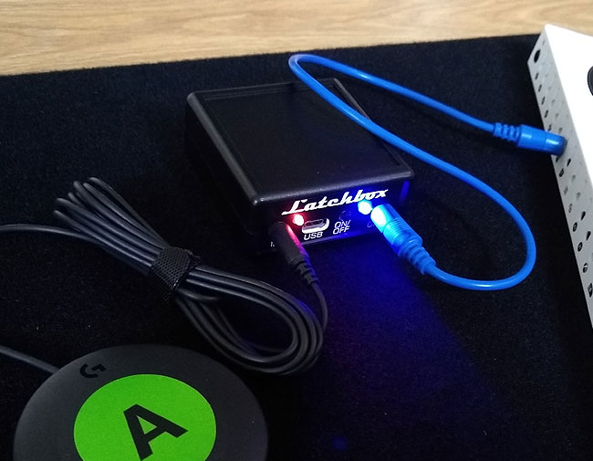

### Tiny Switchy Version 1.4

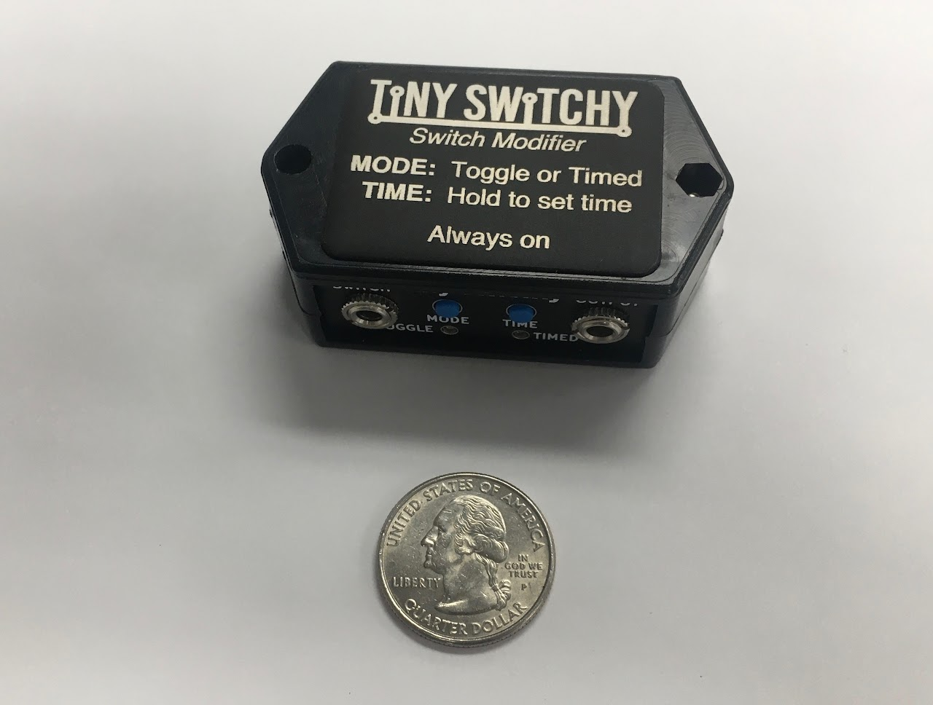

**Information:** [**https://www.tinyswitchy.com/**](https://www.tinyswitchy.com/)

**Purchase:** [**https://www.littlelaketech.com/product/tiny-switchy/1#**](https://www.littlelaketech.com/product/tiny-switchy/1)

There is a lower-cost version of

Cost: $40 USD + Shipping. Does not currently ship to Canada.

* Toggle and timed-output modes
* 3V CR2032 Coin cell battery
* Expected battery life: 3 years
* Small
* >1 A switched current
* Maximum hold time: 68 minutes

## DIY Versions

### Self-Retention for Button on Xbox Adaptive Controller

Link: <http://www.johannes-online.de/wordpress/?page_id=1063>

* Based on request from Melly (<https://meilert.net/>) (<https://twitter.com/melly_maeh>)
* LED to indicate status

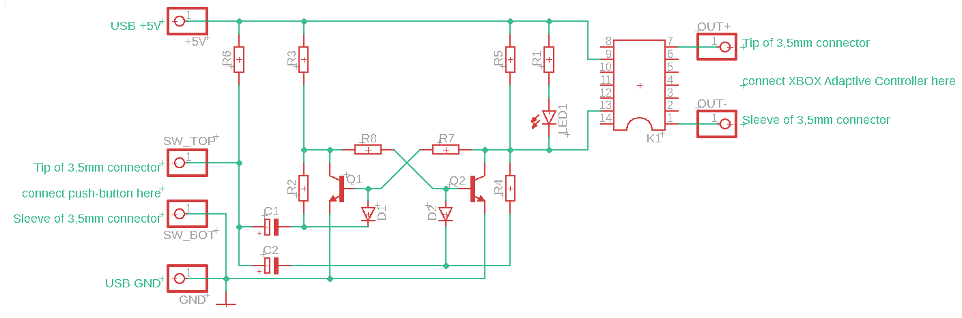

|  |  |  |
| --- | --- | --- |
| **Position** | **Designation** | **Number** |
| C1, C2 | Electrolytic capacitor 22 μF | 2 |
| D1, D2 | Diode 1N4007 | 2 |
| K1 | Reed Relay V23100-V4005-A010 | 1 |
| LED1 | LED 5mm, red | 1 |
| Q1, Q2 | Transistor BC547 | 2 |
| R1, R2, R3, R4, R5 | Resistor 1k Ohm | 5 |
| R6, R7, R8 | Resistance 10k Ohm | 3 |
|  |  |  |

30 mm x 70 mm Grid board

<https://youtu.be/RP3qliKeLuE>

<https://youtu.be/2iWaojsw_O0>

# Requirements

## Goals

|  |  |
| --- | --- |
| G01 | Enable a momentary assistive switch to toggle (latch) a switch controllable device. |
| G02 | To make the device with a relay output capable of driving powered devices. |
| G03 | To make the unit accept 3.5 mm assistive switches. |
| G04 | Useful battery life |

## Functional Requirements

|  |  |
| --- | --- |
| F01 | When off, the toggle circuit must activate (and stay active) when a switch input is triggered. |
| F02 | When on, the toggle circuit must de-activate (and stay off) when a switch input is triggered. |
| F03 | The toggle circuit must contain some form of switch debouncing circuitry to keep operation reliable. |
| F04 | The toggle circuit should default to a non-closed connection. |

## Non-functional Requirement

|  |  |
| --- | --- |
| NF01 | The Toggle Adapter should require no mechanical force to operate. |
| NF02 | The toggle Adapter should have a long battery life. |
| NF03 | The toggle Adapter should use a minimum of electronic parts. |

## Constraints

|  |  |
| --- | --- |
| C01 | The Toggle Adapter must be able to be constructed using basic ‘maker’ tools. |

# Ideation

Some electronic toggle circuit diagrams were sourced from the internet as potential candidates for forming the core of the toggle device. The ideal candidate circuit will have inexpensive parts that are small in number and are easy to construct with basic hand tools.

## Power Source

### AAA Cells

Pros

* Rechargeable

Cons

* Can leak over long time durations

### Lithum 3V Cells

Pros

* High energy density, unlikely to leak.

Cons

- Potential fire risk for some brands/formulations

Comparison

AAA cells are more readily available in stores, but 3V lithium batteries are less common, though CR2032 coin cells are reasonably common.

## User Feedback

Several options should be considered to provide feedback to the user on the operation of the device. Both the state of the adapter (e.g., powered on / powered off) and the state of the output (enabled / disabled) are useful information for a user.

### No Feedback

No feedback is provided to the user.

### LED

High brightness (efficient) green LED used with higher value resistor for lower current draw.

## Test Button

It may be desirable to have a built-in test button so that a secondary user can test whether the toggle adapter is functioning correctly. This may also be used to demonstrate the operation of the device without having to operate the primary user’s input device (e.g., it may be difficult for a secondary user to demonstrate how to use the device if the primary user is using a sip and puff switch).

## Power Switch

Different options for if and how the power of the device would be controlled were considered.

Internal jack switch – a switched 3.5 mm jack could be used to disconnect the power to the device when the input jack or output jack is disconnected from the device.

External switch – a typical sliding button or switch that is toggled when the device should be powered on and off. The primary user may not have the required dexterity to operate this independently. This may also

# Conceptual Design

## Toggle Circuit Options

### Concept 1: Two Transistor Flip-Flop

Two Transistor Flip Flop circuit

This circuit comprises of just two low cost and extremely available transistor and a reasonable number of resistors and capacitors. As no microchip is required, many electronics engineers and hobbyists will find they already posses the needed garden variety parts. The main downsides are that more parts are needed, and that the power consumption of this concept is highest.

Concept 1 prototype was built on Perfboard using parts already in stock. As the parts count is quite high having a PCB design would be best for the final version The diode steering works reliably, as the discrete bipolar transistors have a higher noise immunity than CMOS type input circuitry. The downside comes in the form of higher power consumption, which can be a problem if using batteries.

### Concept 2: 555 Timer IC



555 Timer IC

The venerable 555 Timer IC is used for the second concept. Note that the lower power CMOS version is used here. The chip is easy to solder as it only has eight pins. Power consumption is about 80 micro amps, the second lowest.

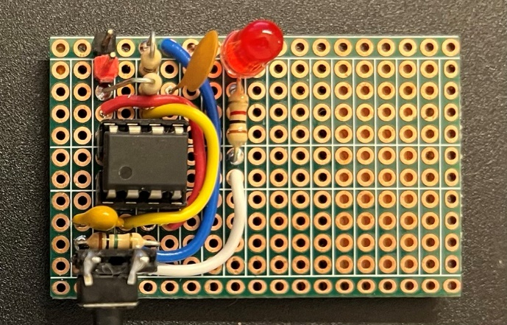

The concept 2 prototype was built on double sided Perfboard using parts ordered from Digi-Key. Note that this circuit makes use of the CMOS version of the 555 timer IC, which is considerably more energy efficient than the original (but still available) bipolar version. Putting this one together was noticeably easier, as the total part count is nearly half that of the discrete transistor version.

### Concept 3: Dual Flip Flop IC

The low power CMOS CD4027BCN Dual Flip Flop IC is used here. While the IC has 16 pins to solder, they can all be soldered quickly because all pins go into a PCB together, and can be soldered quickly due to being placed in rows. Note that this chip has the lowest power consumption of the concepts presented here. Current draw is a mere .7 micro amps, so this circuit could run on a coin cell for months.

Concept 3 prototype was built on double sided Perfboard using parts ordered from Digi-Key. The low power CMOS CD4027BCN Dual Flip Flop IC is used here. While the IC has 16 pins to solder, they can all be soldered quickly as they are in rows, and all go in together. Note that this chip has the lowest power consumption of the concepts presented here. Current draw is a mere .7 micro amps, so this circuit could run on a coin cell for months. An additional bonus of this design is that this IC can be used to make two toggle switches without having to buy another chip. It just requires an extra three resistors, and a capacitor of the same values.

### Concept 4: Quad NAND Gate IC

CD40107BM96 dual NAND gate

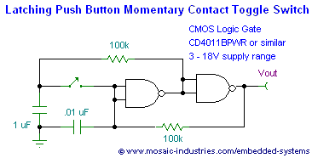

Concept 3 prototype was built on double sided Perfboard using parts ordered from Digi-Key. The low power CMOS CD4027BCN Dual Flip Flop IC is used here. ng, so the design was changed to incorporate a bearing instead.

### Concept 5: Flip Flop with buffered inputs

The CD74HC73E was chosen when it was determined that the input circuitry of the flip flop was vital to the behaviour of the latching circuit when fed with a mechanical switch instead of normally expected CMOS or TTL level circuitry. It was found, that despite identical part numbers, parts from different manufacturers had different input structures suitable for switch inputs. We liked the CD74HC73E because it had an input buffer that could condition a rougher input signal into a usable form, without having to add extra circuitry. Additionally, this chip drew remarkably little power, while still being able to provide decent output drive.

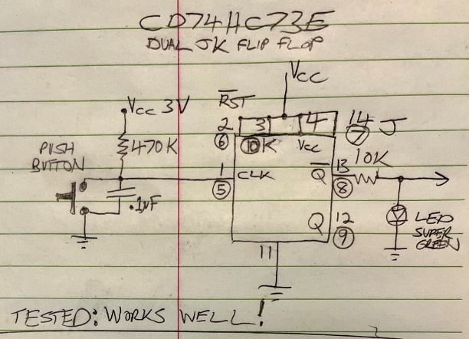

## Circuit Comparison

|  |  |  |  |  |  |
| --- | --- | --- | --- | --- | --- |
|  | Concept 1  Discrete transistor Flip-Flop | Concept 2  555 Timer IC | Concept 3  CD4027 Flip-Flop IC | Concept 4  Quad NAND gate IC | Concept 5 TI CD74HC73E Dual Flip Flop |
| Current Draw  (all at 3.3V) | 959 uA (2.37 mA + LED) | 88-90 uA (1.35+LED) | .2 uA (86.2 uA+LED) | 4.9 uA | .4uA  67uA with LED on |
| Noise Immunity | Excellent  withstood 1.7 VAC RMS) on input | Poor: pin 2 input of 555 highly susceptible to noise .25 VAC RMS | Acceptable:  .85 VAC RMS | Fail  Circuit fails to change states when wires are added. | Excellent  Works even with longer cables |
| Price | Under $20 for core circuitry | Under $20 for core circuitry | Under $20 for core circuitry | Under $20 for core circuitry | Under $20 for core circuitry |
| Projected ease of build | Moderate | Very Easy | Easy | Easy | Easy |

## Toggle Circuit

As the leading design from the comparison table is using the CD4027 IC, we will focus on the CD4027. Note that all the test circuits omitted a solid state relay output circuit, which we will add to the final design, and will become sum of the two schematics below:

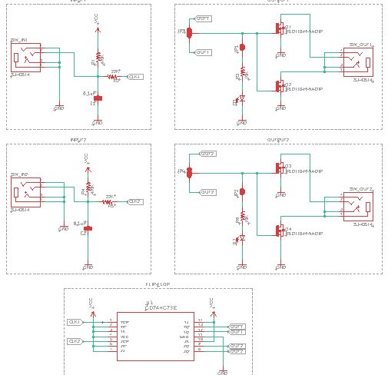

# Prototyping

Several versions of the board were created.

### Dual Version (Two Channels)

### Dual Construction Method Comparison

|  |  |  |  |  |
| --- | --- | --- | --- | --- |
|  | PCB | PCB-A Thru-hole | PCB-A SMD | Protoboard |
| Number of components | 22 |  |  |  |
| Number of polarized components | 7 |  |  |  |
| Number of connections | 72 |  |  |  |
| Cost | $28 CAD |  |  |  |
| Size | 56mm x 50mm |  |  |  |
| Maker Difficulty | Medium | Medium | High | High |

### Mono Version 1 (One Channel)

### Mono Version 2 (One Channel)

### Mono Construction Method Comparison

|  |  |  |  |  |
| --- | --- | --- | --- | --- |
|  | PCB | PCB-A Thru-hole | PCB-A SMD | Protoboard |
| Number of components | 12 | N/A | N/A | N/A |
| Number of polarized components | 4 | N/A | N/A | N/A |
| Number of connections | 46 | N/A | N/A | Additional jumpers needed on protoboards |
| Cost | $20 CAD | N/A | N/A | N/A |
| Size | 56mm x 38mm or 52mm x 44mm | N/A | N/A | Additional area may be needed |
| Maker Difficulty | Easy | Moderate | SMD soldering skills needed | Recommend Experienced builders only |

# OpenAT Switch Latch V1.0

### Channels

This design uses a single channel.

### Visual Feedback

This design has a single green LED. When the output is closed, the LED is on. When the output is open, the LED is off. There is a cuttable junction for disabling this feature.

### Power Source

3V Lithium CR2032 Cell in a thru-hole mounted holder.

### Power Switch

This design has a sliding power switch.

### Enclosure

This design has a multipart 3D printed enclosure fastened with screws. The enclosure consists of a top, bottom, battery cover, and switch slide. The PCB is affixed inside to the top portion of the enclosure. The bottom of the enclosure is affixed to the top of the enclosure using four (4) screws. The battery cover is held in with a single screw.

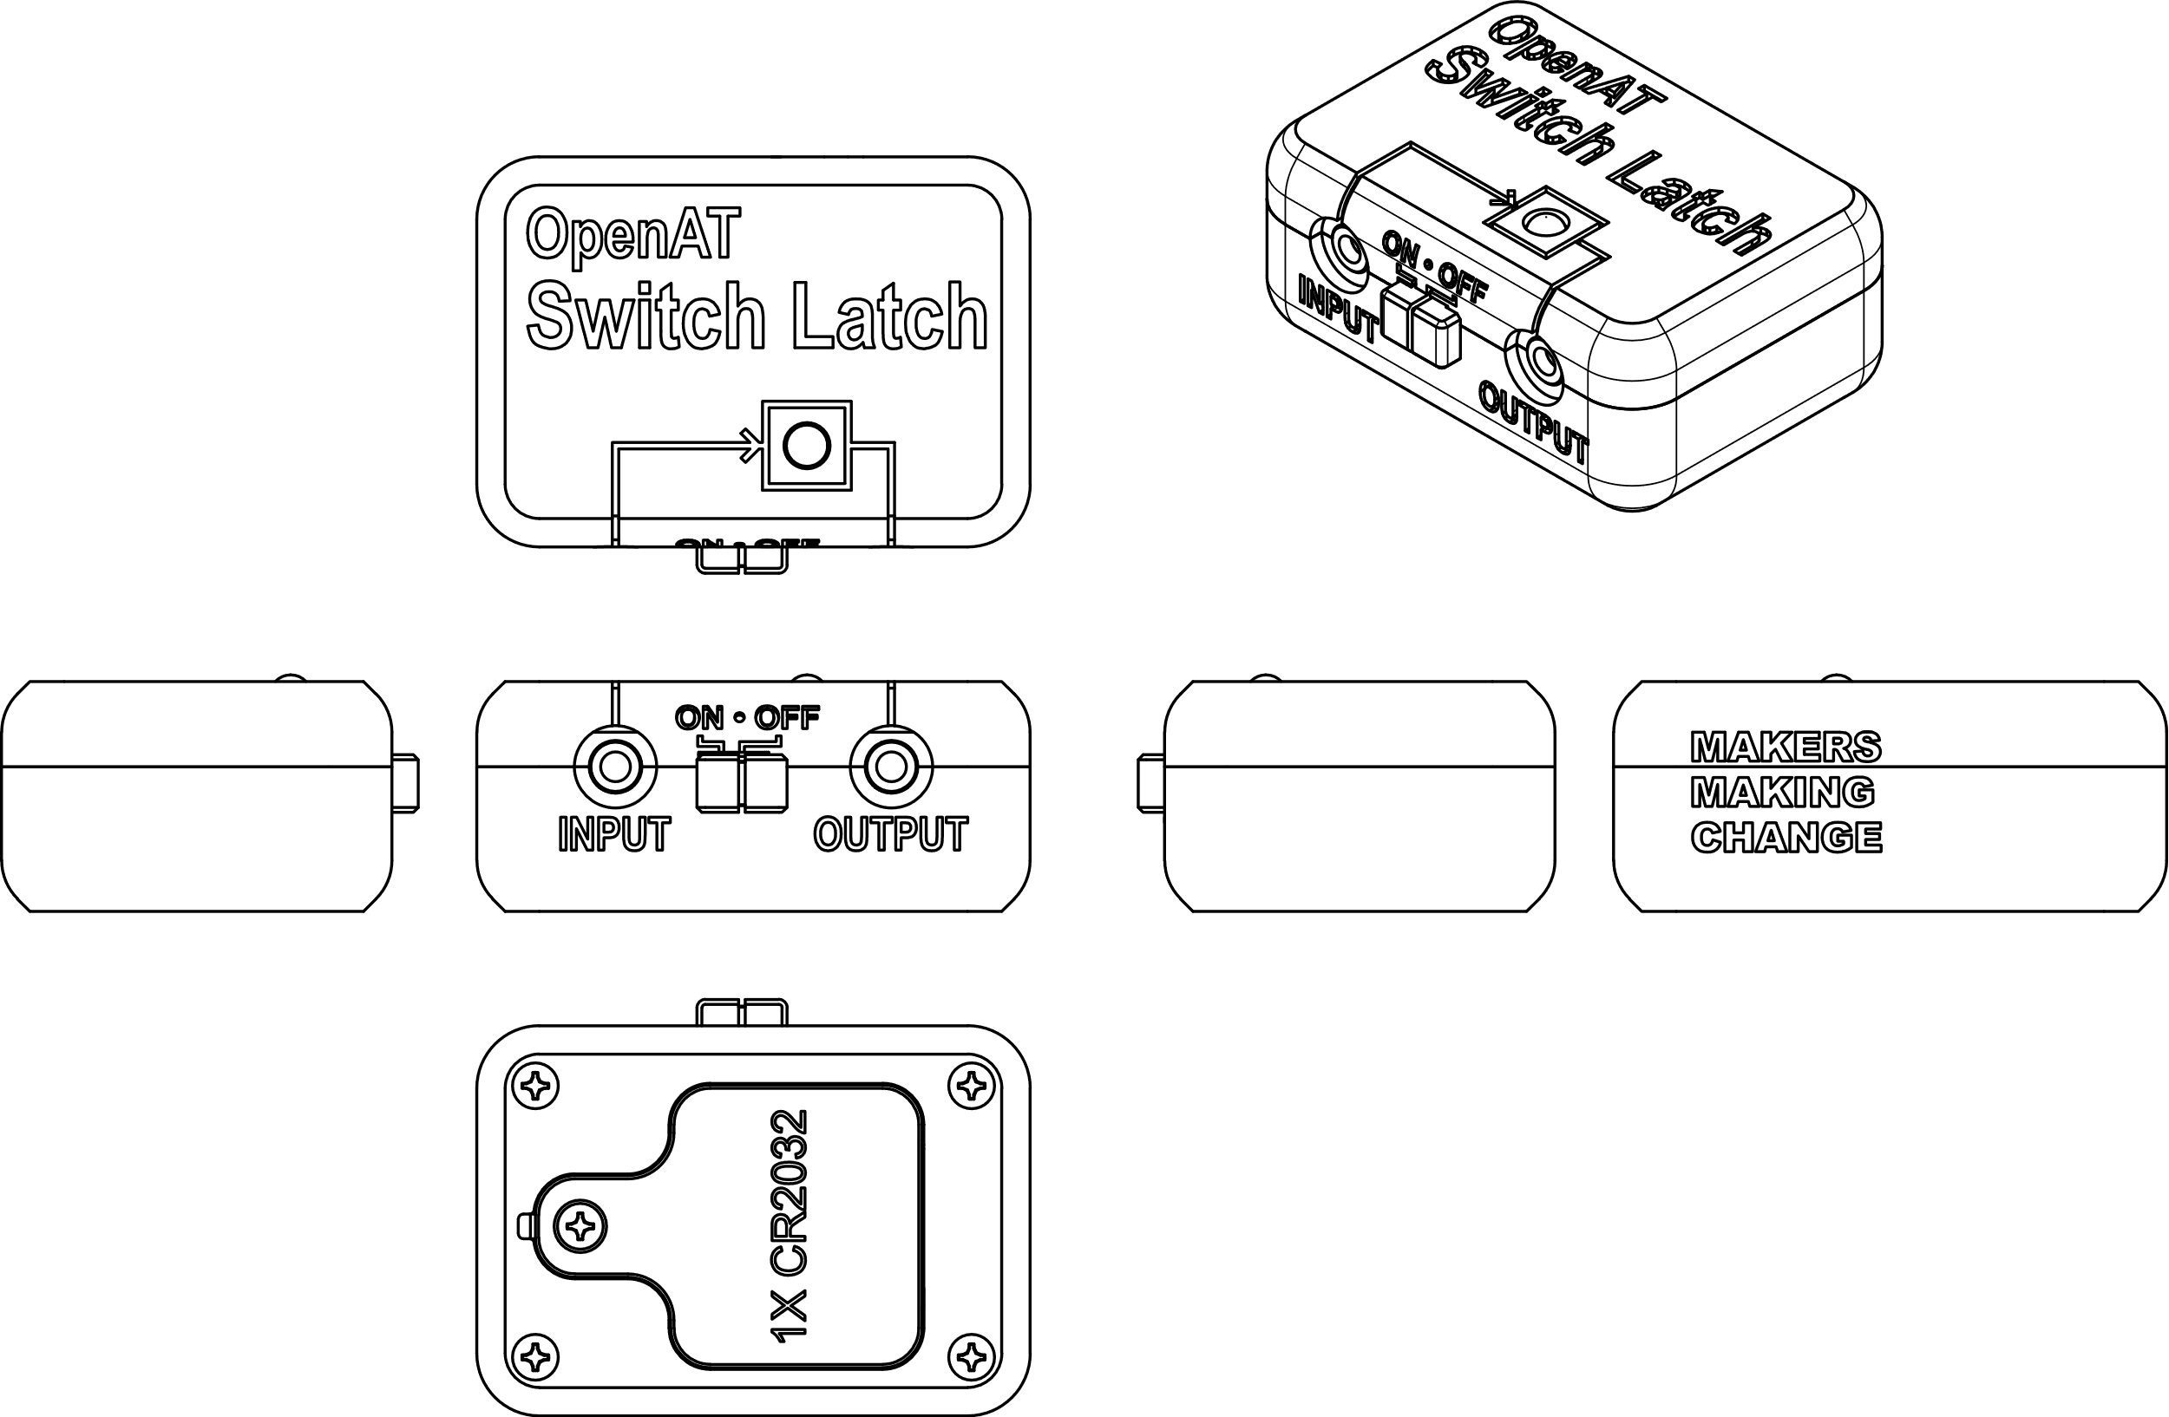

### Design Changes

* Add footprint for right angle switch with a cut-able bypass junction (switch on by default)
* Add Jack with built in switch to act power switch and mark switch pins on PCB (to allow for bypass in case of failure I.e. Digi-Key **SJ-3566AN** or equivalent)
* Add Clearance around the PCB and battery holder (2.5-3 mm?)
* Add central hole on PCB same size as 4 corner holes.
* Change Dimensions of PCB to 60 x 40 mm
* Move alternate output cut-able trace to under battery case (allows for testing but not final use)
* Move input and output jacks apart as much as possible (but allow 1mm clearance to case posts)
* Move the power switch between input and output jacks
* Change the JK flip flop IC to Texas Instruments CD74HC73E, as CD4027 from Fairchild was no longer available from Digi-Key or Mouser, and the newer revisions from other vendors had gate input structures that proved unsuitable for use with a mechanical switch input, as this type of circuit is normally fed with pulses from another logic IC

## Printed Circuit Board

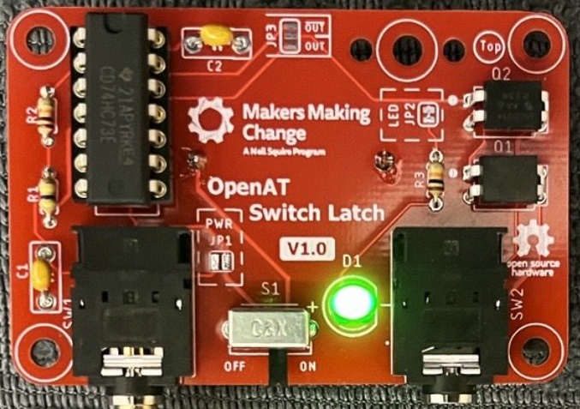

### Theory of Operation

Pressing the button causes the input of the first JK Flip Flop to go low. This triggers the Flip Flop output to change to its opposite state, and remaining that way (even after the button is released, and the input goes high again). Only a fresh button press will change the output state. The output of the Flip Flop feeds a green LED for state indication, via a 10K resistor. The Flip Flop output is also connected to two MOSFETs, which are wired together to function as a solid-state relay. Thus, when the Flip Flop output goes high, and the LED turns on, the output jack also becomes conductive, turning on any connected and activatable device.

### Solder Junctions

This PCB design incorporates three solder junctions that can be modified to change the operation of the device.

**JP1**

* Default: Unsoldered
* Purpose: This can be soldered to bypass the input jack switch (i.e., the device’s power is controlled only by the power switch)

**JP2**

* Default: Soldered
* Purpose: This can be cut to disable the Output LED.

**JP3**

* Default: Unsoldered
* Purpose: Reverse toggle switch operation

## Opportunities for Improvement

* Modify design with extra capacitor (or diode) to boost the noise immunity somewhat.
* Use non polarized ceramic capacitor for power decoupling.